**Final Year B. Tech., Sem VII 2022-23**

**Cryptography And Network Security**

**PRN/ Roll No: 2020BTECS00206**

**Full Name: SAYALI YOGESH DESAI**

**Batch: B4**

**Assignment No. 15**

1. **Aim:**

Analysis of intrusions using snort software.

1. **Code:**

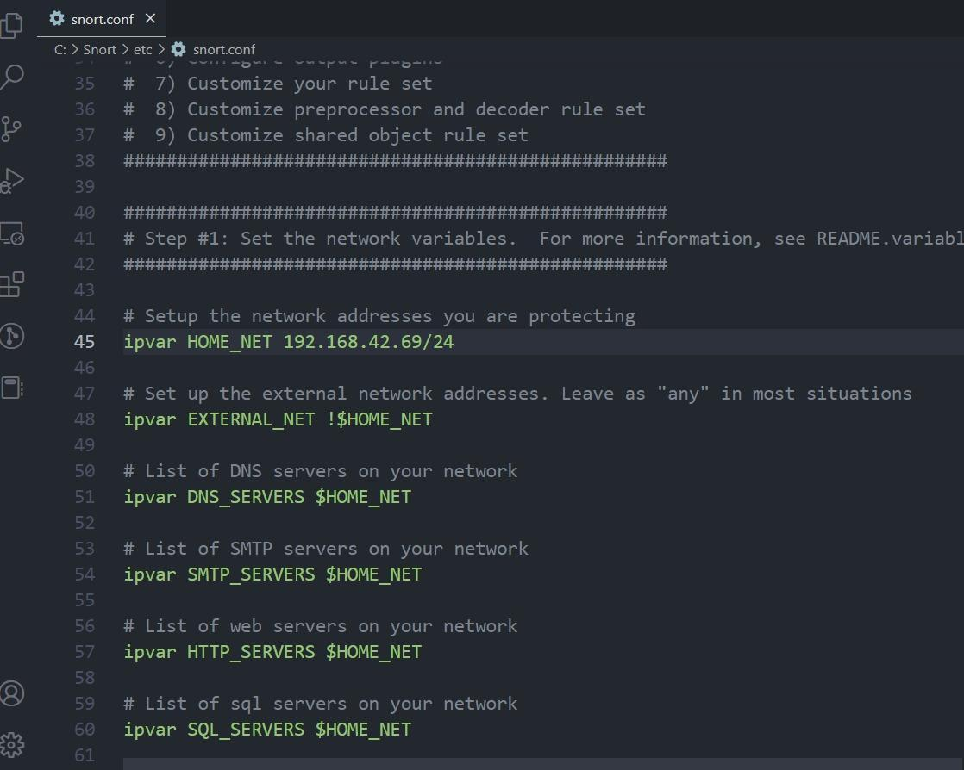

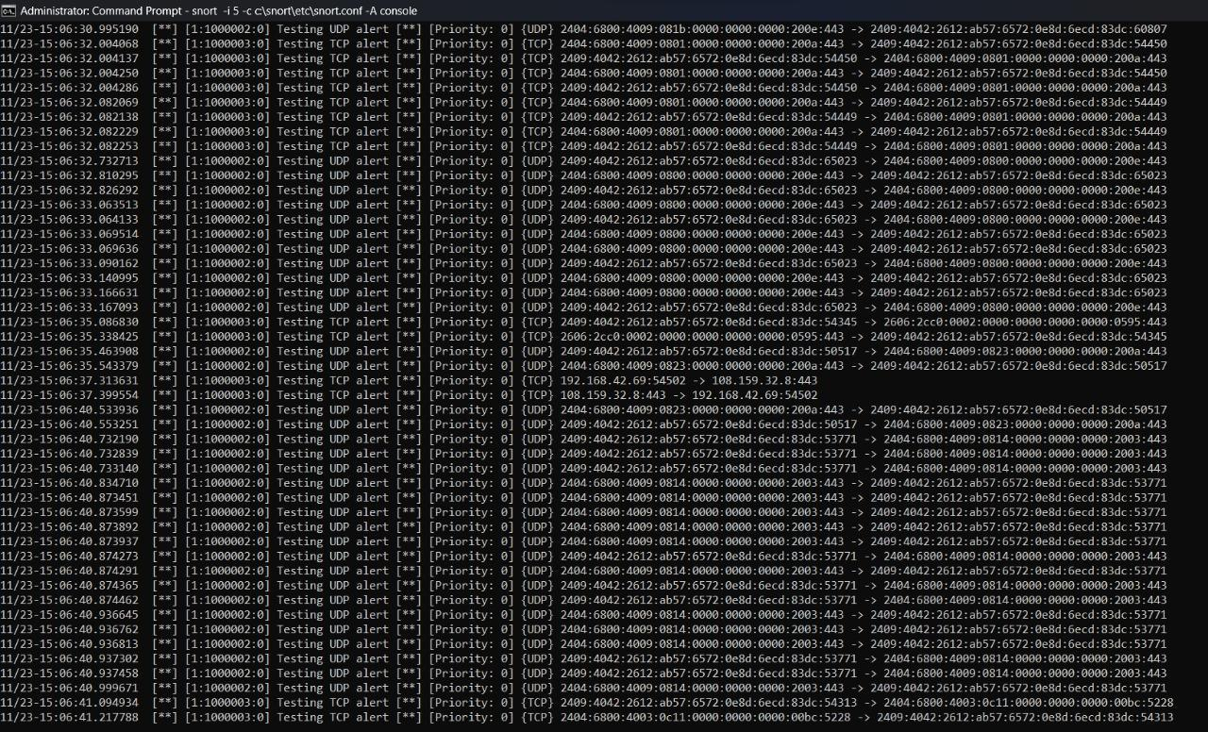

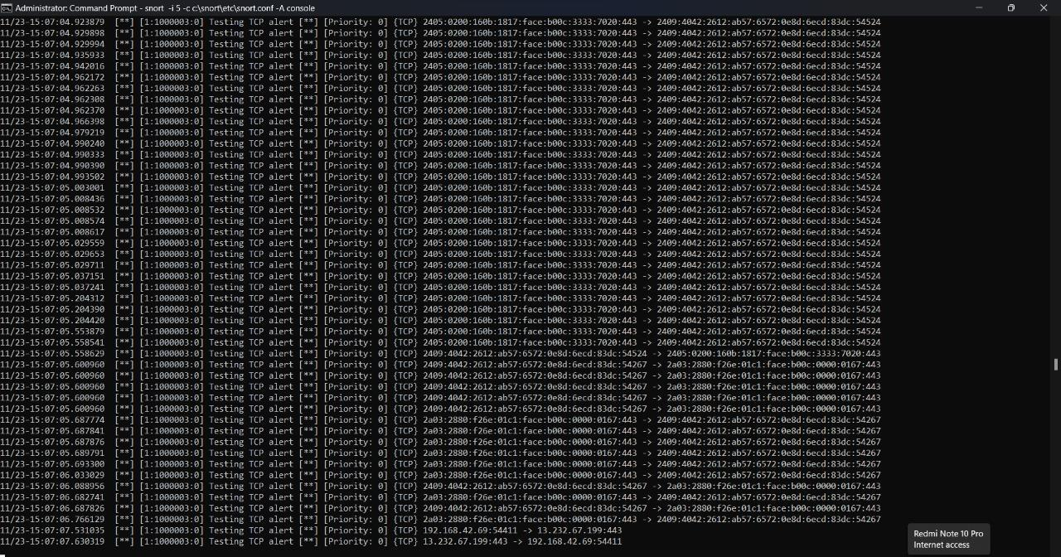

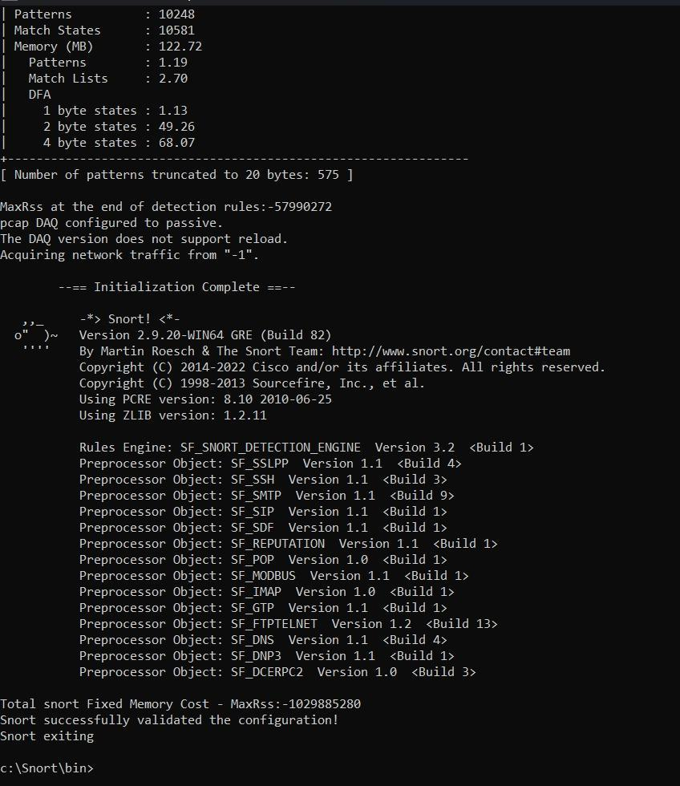

1. **Conclusion:**

Successfully created digital certificate named Sayali.